The Secretary,

New Town SDA Church,

Sunyani.

Dear in Christ,

**LETTER OF APPRECIATION TO NEWTOWN SDA CHURCH**

We would like to take this opportunity to express our hearfelt gratitude to the pastor, elders and church members for the assistance you rendered to us during our handing over service which took place on February 6, 2021.

Again, our patrons and entire fellowship collectively pass our sincere appreciation for your effort in supporting us during the handing over harvest.

We pray that the church enjoys God’s blessings for the kindness and replenish all your losses as a result of your support towards our programmes.

Thank you.

Yours in Christ,

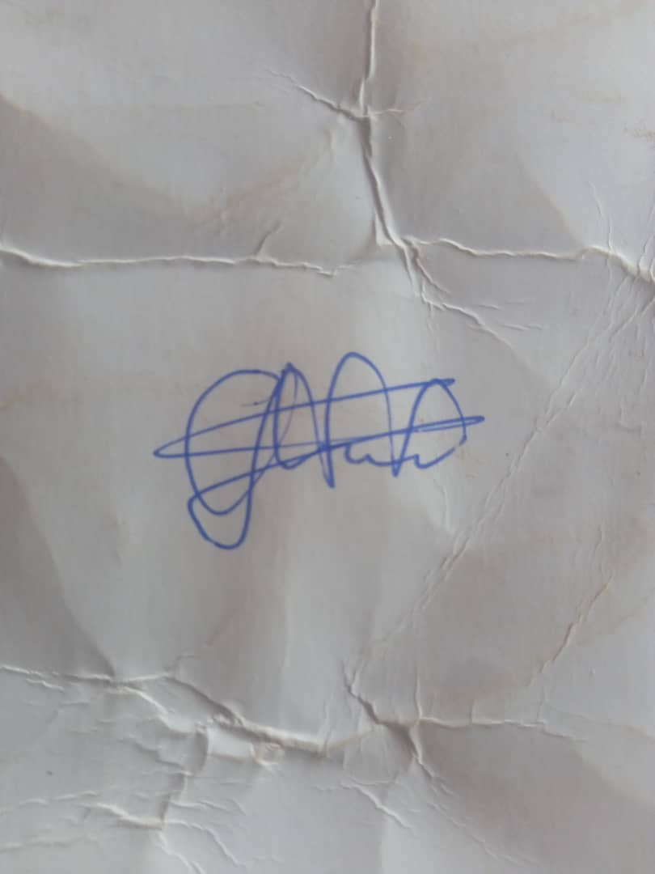

Ellen Ama Dansowaa Kwan

(Secretary)

***For any enquiries, you may call any of the contacts above or email us at*** [guenrcucg@gmail.com](mailto:guenrcucg@gmail.com)

**EXECUTIVE COMMITTEE**

**CLEMENT ABAGNA WEWOTAH** **PRESIDENT**

**0248639895**

**|**

**KINGSFORD BADU**

**VICE PRESIDENT**

**0200021392**

**|**

**ELLEN DANSOWAA**

**SECRETARY**

**0245840092**

**|**

**LINA OFORI**

**SECRETARY**

**0550493142**

**|**

**KOFI DEI JUNIOR**

**CHIEF DEACON**

**0543317307**